Geospatial Info Solutions:
Admin Login Sequence Diagram
Admin
LoginPage
BL:Cls_Login()
DAL:SqlHelper()
Database
1 : Admin Login
2 : ValidateUser()
3 : ExecuteNonQuery()
4 : ExecuteComand()
5 : Return QueryResult()
6: ResponseForValidateUser()
Sequence Diagram for add municipal taxes
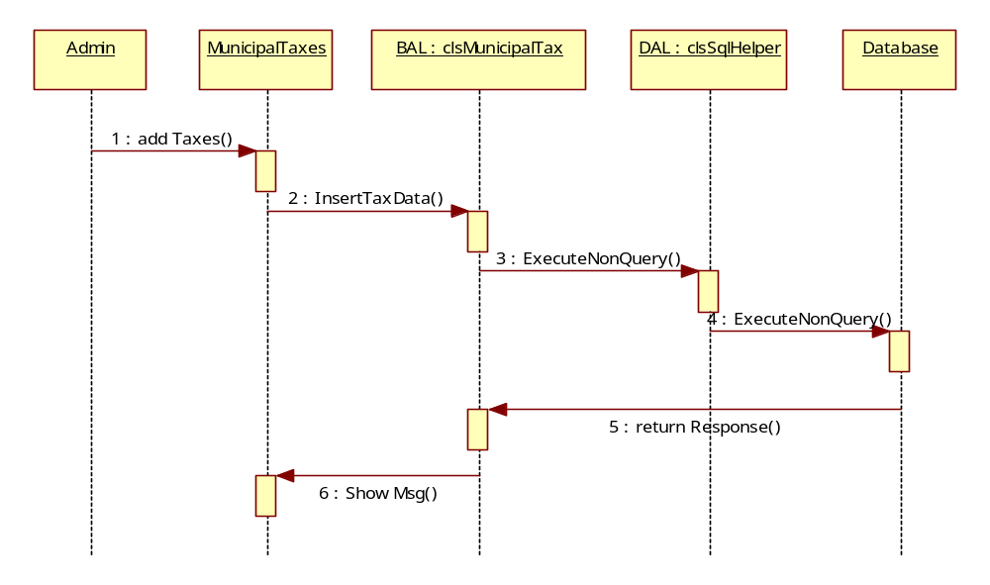
Sequence diagram for Manage Local Data
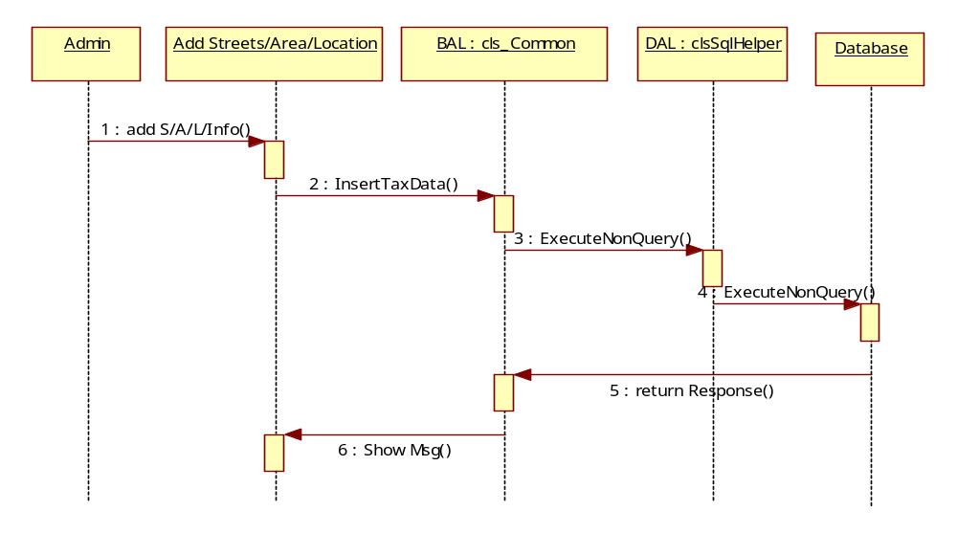
Sequence Diagram for Building Approvals
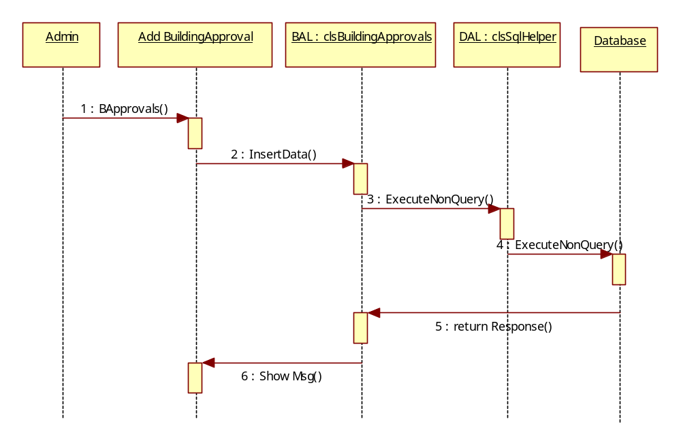

Sequence Diagram for Users Municipal Bills

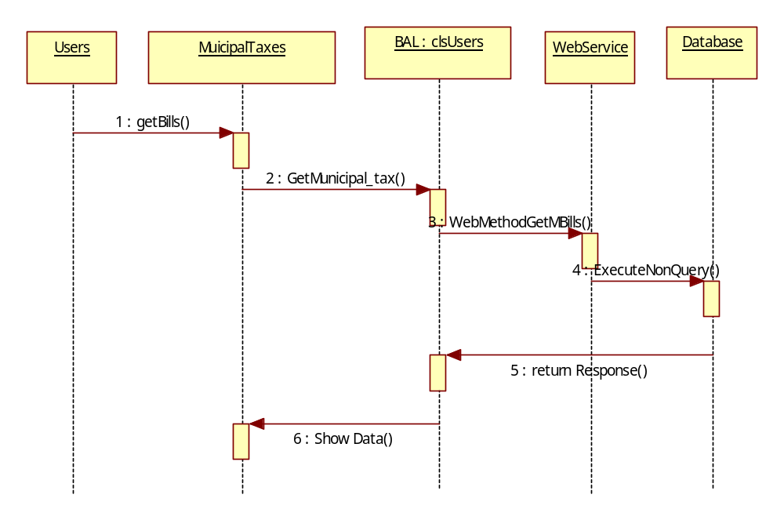

Sequence Diagram for Users Electricity Bills

